**Angular CLI:** The Angular CLI is a tool to initialize, develop, scaffold and maintain Angular applications. It is recommended to use angular cli for creating angular apps as you don't need to spend time installing and configuring all the required dependencies and wiring everything together and saves our time.

* Ng new new-app –skip-install (it will only creates file won’t do npm install)
* ng new new-app –dry-run (it won’t create any files it will only tell you which file it will create)
* ng new new-app –prefix acme(change the prefix of selector in component)
* ng new new-app --skip-tests (no spec files)
* ng new new-app --routing (to create app-routing modules)
* ng new new-app --style scss(if you want to use sass by default for new app)
* ng –help
* –save-dev (this will save the installed in dev dependency)

**Configuring angular-cli after creation**

* ng set defaults.styleExt scss (to change the style to scss)
* ng set defaults.styleExt scss -g ((to change the style to scss in global angular-cli.json for all cli projects)

**Linting**

* ng lint
* ng lint –help
* --fix (automatically fix the fixable problems)
* --format stylish (lint anf format the o/p)

**Blueprints**

* ng generate component home-catpotal or ng g c home-catpotal

options

* + –flat (should a folder be created)
  + –inline-template or -it(will the template be in the .ts file)
  + –inline-style or -is(will the style be in the .ts file)
  + –spec (generate a .spec file ?)
  + –view-encapsulation or –ve (view encapsulation strategy)
  + –change-detection –cd (change detection stategy)
  + –dry-run or –d
* ng g d app-directive
* Services
  + ng g s app-data (it will create service but it won’t be registered to any module)
  + ng g s app-data –m app.module(this will register the service inside app.module)
* ng g cl model/customer (it will create a class inside a model folder)
* ng g I model/person (it will create a interface inside a model folder)
* ng g enum model/gender (it will create a enum inside a model folder)
* ng g c p shared/init-caps (it will create a pipe inside a shared folder)
* **Module**
  + ng g m login (create a module inside login folder)
  + ng g c login -m login/login.module (it will create a component inside login folder and update the login.module)
* ng set defaults.component.flat true (Do not create a folder for components)
* ng set defaults.component.flat true (Do not create a folder for directives)
* ng g m login –routing app-data(it will create login.module and also routing module and register routing module in login.module)
* ng g guard <guard_name> (generate a authguard)

Making Build

* Files contained inside dist folder:
  + Inline.bundle.js (webpack runtime=>to put everything together for us so that the application should work)
  + main.bundle.js (the code we write)
  + polyfills.bundle.js (polyfills for different browsers)
  + styles.bundle.js (where all the styles is located)
  + vendor.bundle.js (contain angular and the other third party or vendor files )
* npm i source-map-explorer –save-dev
* .node_modules/.bin/source-map-explorer dist/main.bundle.js (it will display which component structure is consuming how much memory for main.bundle.js)
* .node_modules/.bin/source-map-explorer dist/ vendor.bundle.js (it will display which component structure is consuming how much memory for vendor.bundle.js)

Environment

* Indicates which file to use between environment.prod.ts and environment.ts

**Target**

* Defines how (and if) the files are optimized

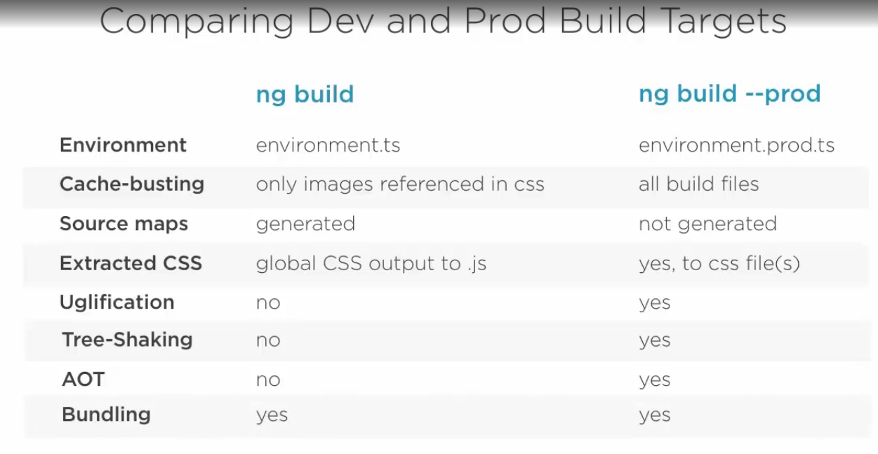

* Dev build
  + ng build --target=development –environment=dev
  + ng build --dev -e=dev
  + ng build --dev
  + ng build
* Production build
  + ng build --target=production –environment=dev
  + ng build –prod -e=prod
  + ng build –dev

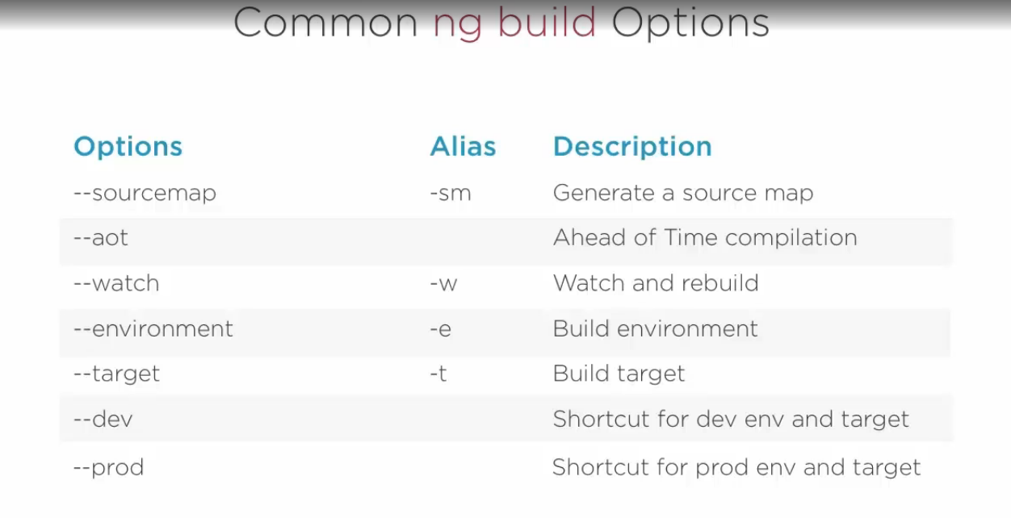

* ng build –prod –sm (to run source map inside production build)

**Serve**

* all build options will be available during “ng serve”

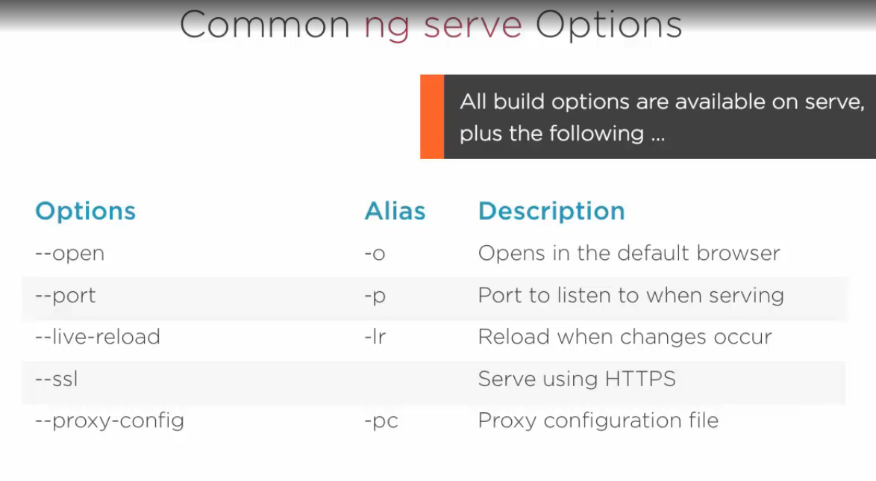

* ng serve –prod

**Eject**

* ng eject (to remove angular-cli from your project)

**Test**

* ng test
* ng test –sr or ng test –w false (run test for single time only)

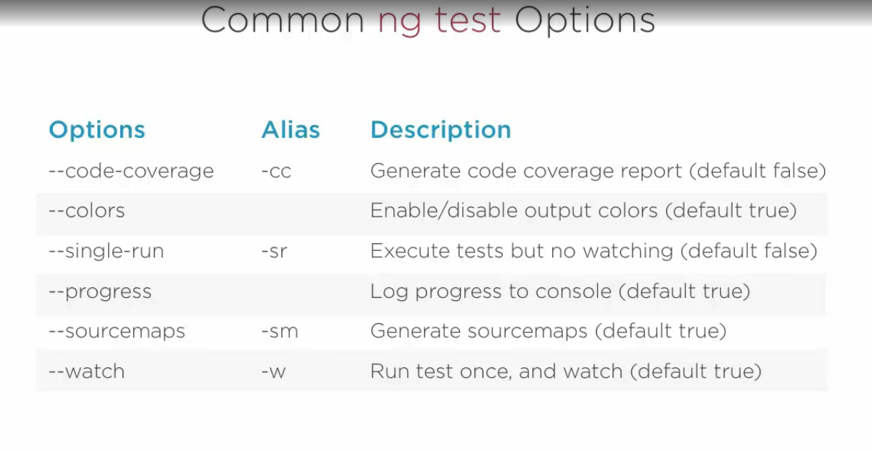

Note:

* any external .js file will be inserted inside scripts array in angular-cli.json
* any external .css file will be inserted inside style array in angular-cli.json